**PAGE 1**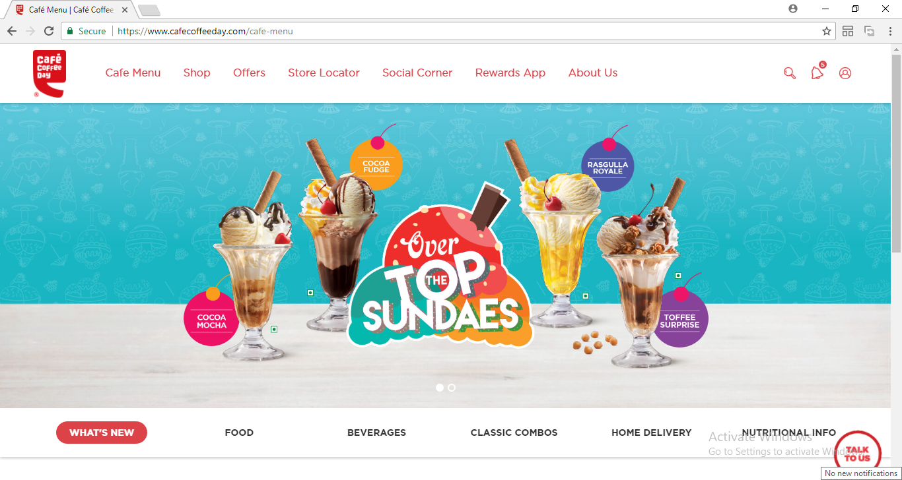

**On click of High lighted area, go to Page2**

**PAGE 2**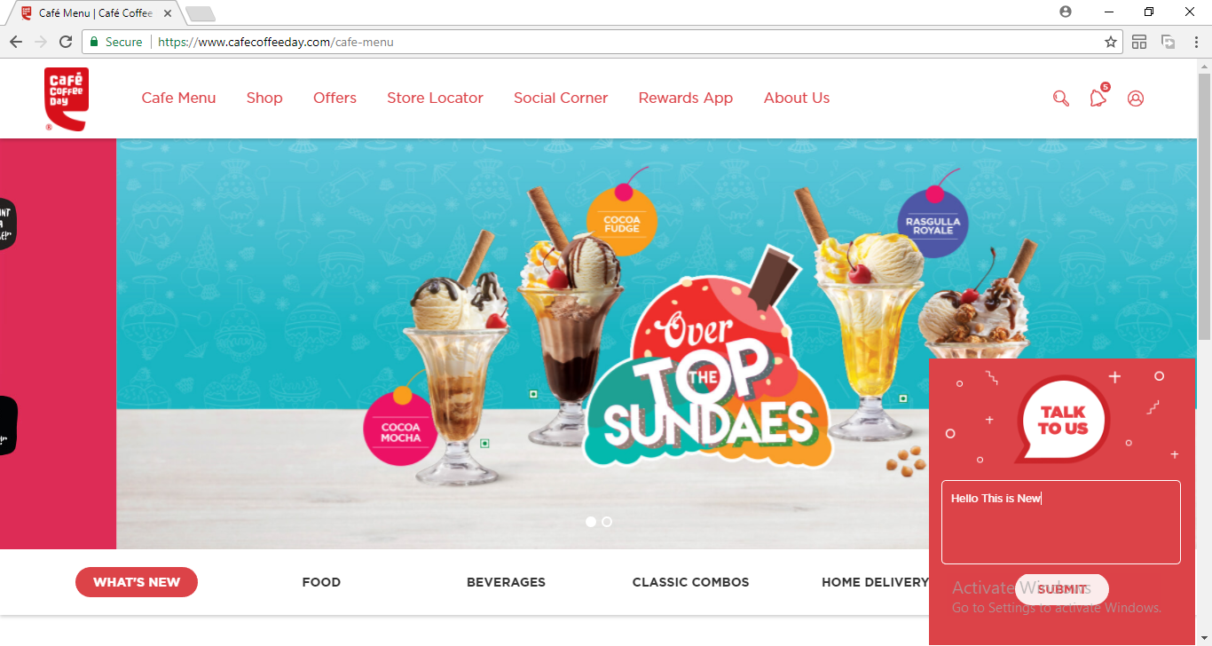

**On click of submit, go to Page 3**

**PAGE 3**